Appsters Industry Page Layout
AUTOMOTIVE
Laid out fold by fold against www.appsters.io/industry
 | DETAIL
Slug | automotive-software-development
Meta Title | Automotive App Development Company | Hire Top Developers
Meta Description | Build connected car, fleet and dealership apps with Appsters. Telematics, diagnostics and OBD II expertise. Talk to our automotive app developers today.
Layout Source | www.appsters.io/industry
Live Folds | 23
New Blocks Required | 3
FOLD 1: Hero Banner
Hero Banner
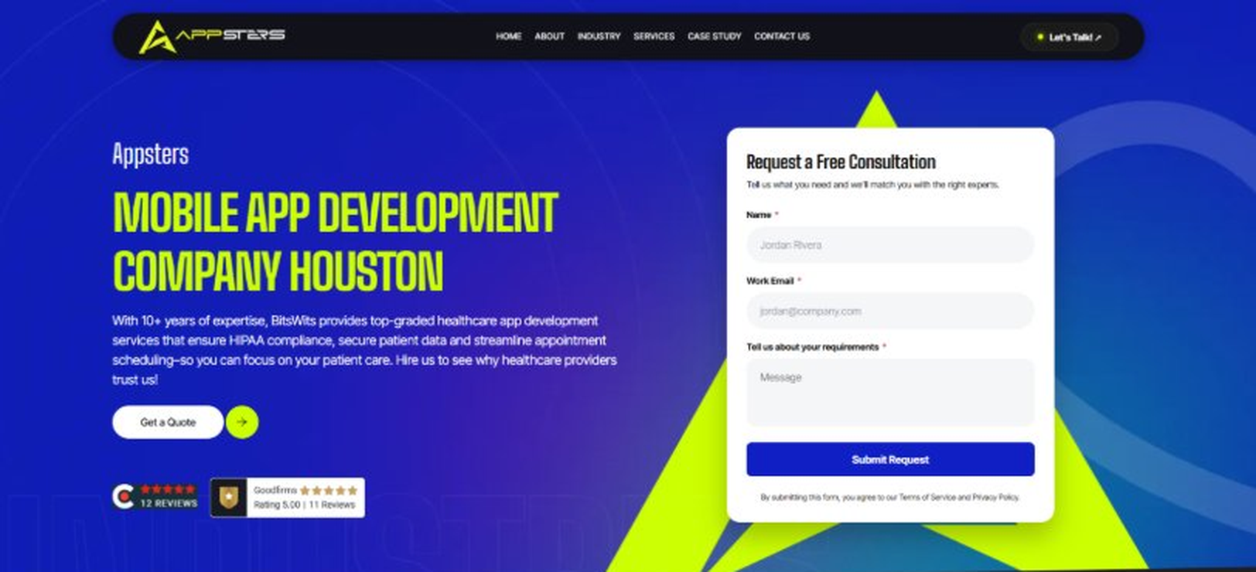
Current live page, www.appsters.io/industry
Copy For This Fold
PAGE ELEMENT | COPY (WORD FOR WORD)
H1 (Page Heading) | An Automotive App Development Company Building Platforms That Keep Drivers Moving
Body Copy | Cars are turning into software platforms on wheels, and drivers expect apps that keep pace. As an automotive app development company, Appsters builds Automotive apps that connect vehicles, dealerships, and drivers through reliable, real-time technology. We build platforms for OEMs, dealership groups, and mobility startups who need software as dependable as the hardware it runs on.
FOLD 2: Marquee Strip
Marquee Strip: Turn Your Wildest Ideas Into Powerful Digital Products
Current live page, www.appsters.io/industry
 | DETAIL
Status | No copy change
Build Notes | No new copy in the source document for this fold. Keep the live block exactly as it is.
FOLD 3: Stats Counter
Stats Counter: Work With A Local Mobile App Developer In Houston
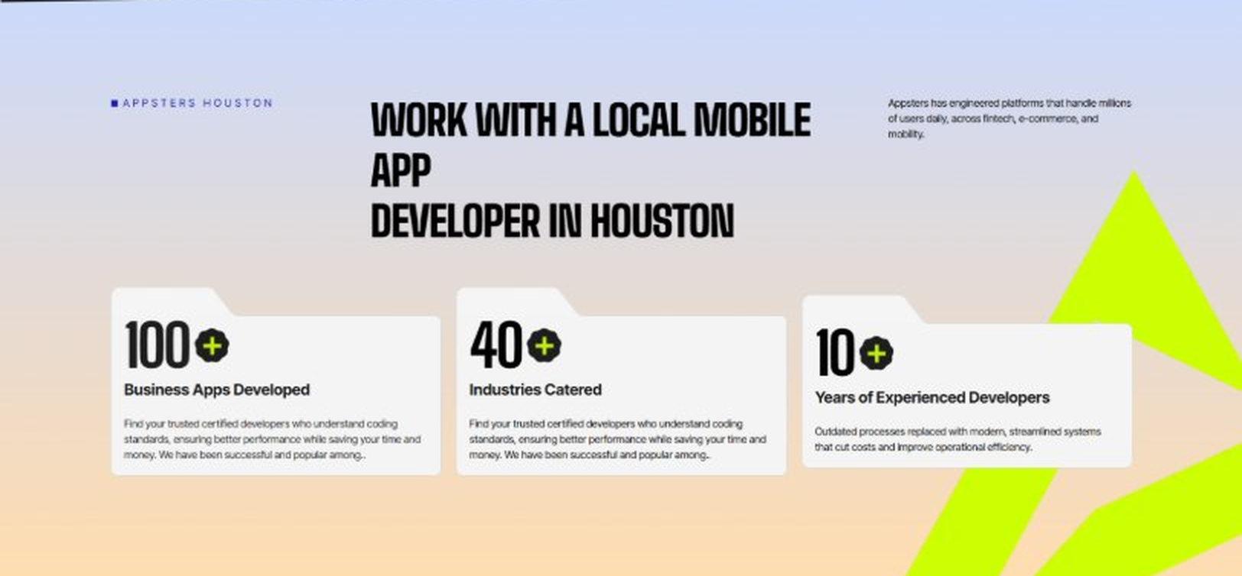
Current live page, www.appsters.io/industry
Copy For This Fold
PAGE ELEMENT | COPY (WORD FOR WORD)
H2 (Section Heading) | Awarded For Building Automotive Apps That Perform Under Real Driving Conditions
Body Copy | Our Automotive app development work has earned recognition for telematics accuracy, connectivity reliability, and measurable customer satisfaction gains. Appsters has been recognized for delivering platforms that track vehicle health precisely, handle poor connectivity gracefully, and stay stable across fleets of every size. Every award reflects tested performance, not a showroom pitch.
Stat 1 Number | 40+
Stat 1 Label | Industries Served
Stat 1 Copy | Our experience spans social platforms, marketplaces, fintech, healthcare, and more, with solutions adapted to each sector's demands for security, AI, compliance, and user adoption.
Stat 2 Number | 3000+
Stat 2 Label | Apps and Solutions Delivered
Stat 2 Copy | Thousands of projects executed with an emphasis on speed, AI adoption, stability, and clear ROI across both startup and enterprise environments.
Stat 3 Number | 60+
Stat 3 Label | AI Models Deployed
Stat 3 Copy | Every model is designed for high accuracy, reliable outputs, and performance at scale for mission-critical workflows and more.
FOLD 4: Marquee Strip
Marquee Strip: Mobile App Development Services
Current live page, www.appsters.io/industry
FOLD 5: Services Grid
Services Grid: Our Comprehensive Mobile App Development Services In Houston
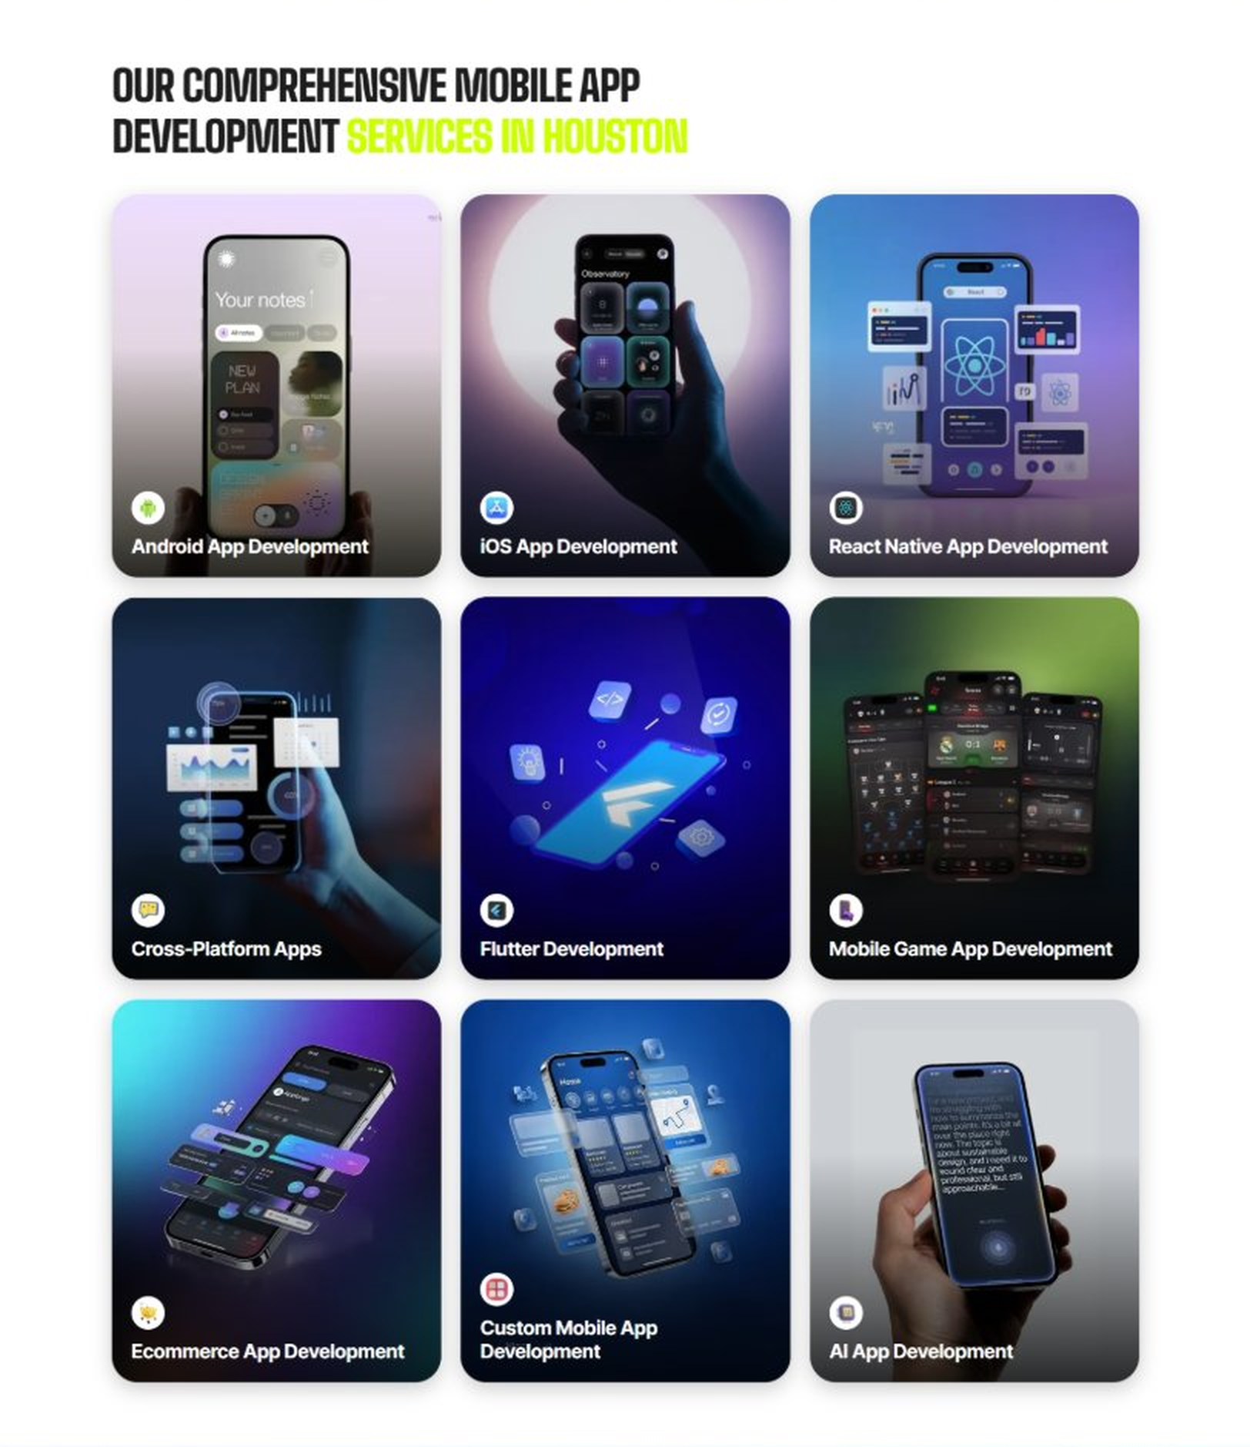
Current live page, www.appsters.io/industry
Copy For This Fold
PAGE ELEMENT | COPY (WORD FOR WORD)
H2 (Section Heading) | Automotive Application Development Services Built For Drivers Who Expect More
Service 1 Heading | Automotive Finder App Development
Service 1 Copy | As Automotive app developers, we build discovery tools that help buyers find the right vehicle, dealership, or service center based on real inventory and location data instead of outdated listings.
Service 2 Heading | Food Ordering App Development
Service 2 Copy | Connected car platforms increasingly double as in-vehicle commerce hubs, and our food ordering app developers know how to build ordering flows drivers can use safely through voice or dashboard integration without taking their eyes off the road.
Service 3 Heading | Food Delivery App Development
Service 3 Copy | As a food delivery app development company, we build fulfillment layers that connect to fleet and delivery vehicle apps, giving delivery drivers routing, order details, and proof-of-delivery tools in one interface.
Service 4 Heading | Discounts App Development
Service 4 Copy | Our Automotive discounts app development work helps dealerships and service centers reward loyal customers with service discounts, referral perks, and maintenance reminders tied directly to a vehicle's service history.
Service 5 Heading | Automotive Review & POS Software Development
Service 5 Copy | For dealerships and service centers, our POS software development company expertise connects service billing, customer reviews, and parts inventory into one system, so managers see real numbers without chasing paper invoices.
FOLD 6: Case Study CTA
Case Study CTA: HELPP
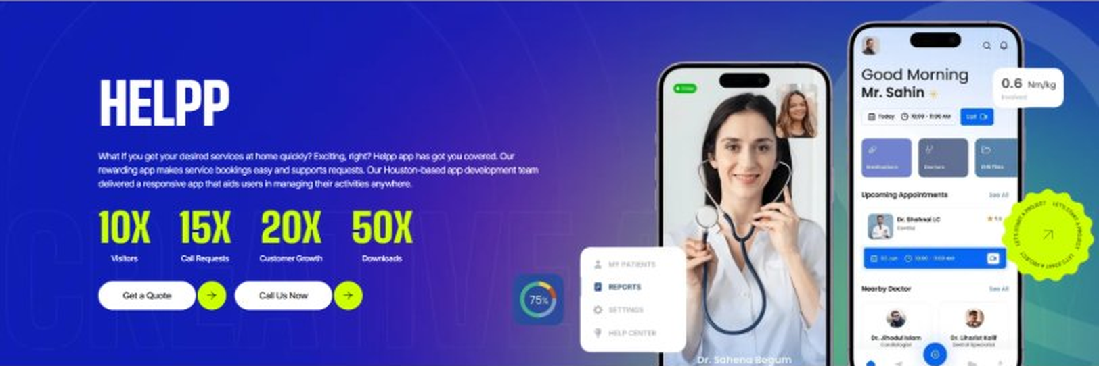
Current live page, www.appsters.io/industry
Case Study Remains Same
FOLD 7: Testimonials
Testimonials: Real Stories From People Who Wanted What’s Next
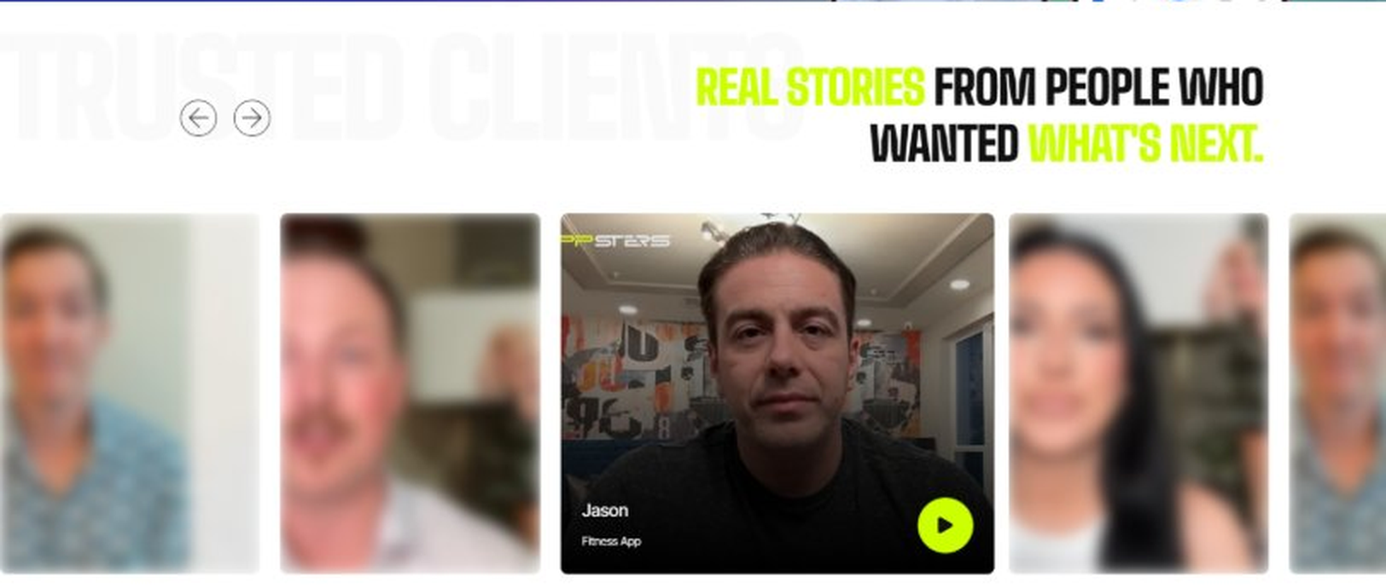
Current live page, www.appsters.io/industry
Copy For This Fold
PAGE ELEMENT | COPY (WORD FOR WORD)
H2 (Section Heading) | What Our Clients Say
Testimonial 1 Quote | "We'd been promised a real telematics platform twice before and got a glorified spreadsheet both times. Appsters actually delivered live diagnostics that our service advisors use every single day now."
Testimonial 1 Attribution | Gary Holcomb, VP of Service Operations
Testimonial 2 Quote | "Our dealership group runs twelve locations and inventory used to be a mess between them. That problem is basically gone now. I still find that a little hard to believe some mornings."
Testimonial 2 Attribution | Denise Farrow, General Manager
Testimonial 3 Quote | "I manage a delivery fleet, not a car dealership, and I was worried Appsters wouldn't understand our side of things. They did, and the routing improvements paid for the project within four months."
Testimonial 3 Attribution | Victor Ashby, Fleet Operations Manager
Testimonial 4 Quote | "Customer complaints about service wait times dropped noticeably after we rolled out the new booking and status app. Nobody's calling to ask when their car will be ready anymore; they just check the app."
Testimonial 4 Attribution | Rosalind Meeks, Service Center Director
Testimonial 5 Quote | "What impressed me was how the team handled our legacy hardware. Most vendors wanted to rip and replace. Appsters found a way to work with what we already had installed in the fleet."
Testimonial 5 Attribution | Cole Fenwick, Chief Technology Officer
Source document note: Testimonial fold, design TBD after content
FOLD 8: Technology Logo Strip
Technology Logo Strip

Current live page, www.appsters.io/industry
FOLD 9: Why Choose Us
Why Choose Us: Compelling Reasons To Choose Us As A Trustable App Development Company In Houston
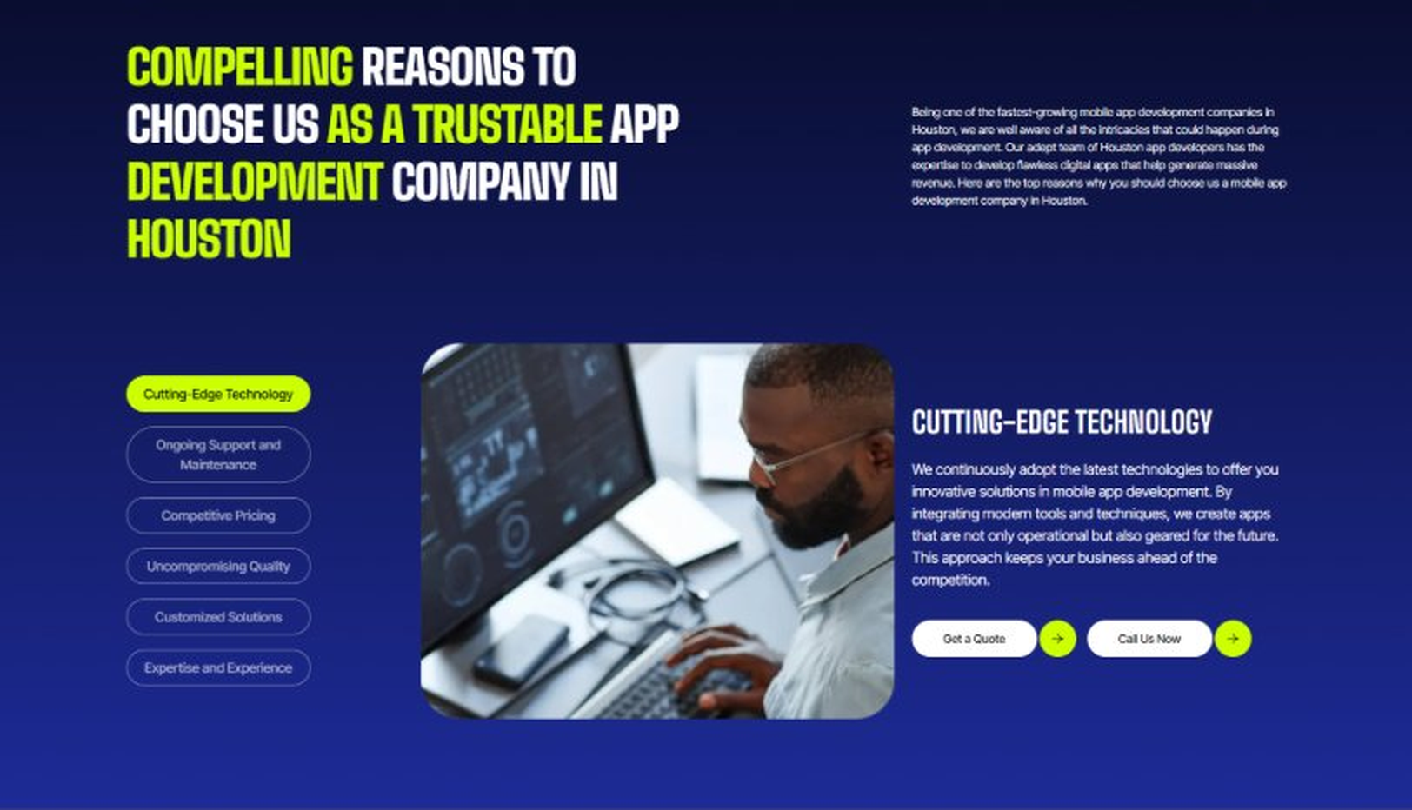
Current live page, www.appsters.io/industry
Copy For This Fold
PAGE ELEMENT | COPY (WORD FOR WORD)
H2 (Section Heading) | Why Dealerships And Fleets Choose Appsters As Their Trusted Automotive App Partner
Body Copy | Choosing an automotive app development partner shapes whether your platform earns driver trust or gets deleted after the first bad experience. Our team blends engineering discipline, hardware expertise, and product thinking to build apps drivers actually rely on.
Reason 1 Heading | Reliability-First Architecture
Reason 1 Copy | We design every feature around consistent performance, backed by real connectivity and telemetry data rather than assumptions.
Reason 2 Heading | Built-In Safety Standards
Reason 2 Copy | Driver distraction rules aren't an afterthought. Our systems are designed around safe interaction patterns from the first wireframe.
Reason 3 Heading | Fleet-Scale Engineering
Reason 3 Copy | Our architecture is stress-tested for large fleet deployments, so scaling from ten vehicles to ten thousand doesn't require a rebuild.
Reason 4 Heading | Hardware Integration Depth
Reason 4 Copy | From OBD-II ports to OEM telematics units, we have real experience connecting software to the hardware that actually exists in vehicles today.
Reason 5 Heading | Transparent Development Cycles
Reason 5 Copy | We follow sprint cadences with review checkpoints and shared roadmaps, so clients always know what's shipping and what's improving.
Reason 6 Heading | Long-Term Platform Thinking
Reason 6 Copy | We structure apps as ecosystems that evolve with new vehicle models and connectivity standards, built for longevity rather than a single launch cycle.
FOLD 10: Sector Tabs
Sector Tabs: Serving 40+ Sectors With Mobile App Development In Houston
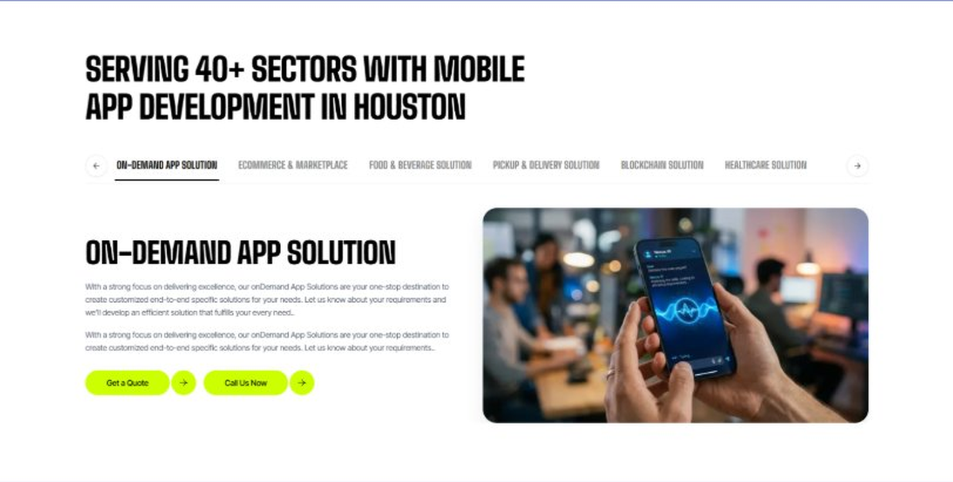
Current live page, www.appsters.io/industry
Copy For This Fold
PAGE ELEMENT | COPY (WORD FOR WORD)
H2 (Section Heading) | Automotive App Solutions Built For Every Part Of The Driving Experience
Body Copy | Appsters delivers Automotive app solutions that cover everything from dealership operations to connected vehicle tools. Our systems are architected by senior Automotive app developers who focus on reliability, safety, and stable performance. Through our Automotive app development services, we help organizations build platforms that feel dependable, modern, and built to handle real vehicle data at scale.
Solution 1 Heading | Event Management Apps
Solution 1 Copy | Our event tools help dealerships and manufacturers coordinate auto shows and launch events, managing vendor logistics and attendee schedules from one dashboard.
Solution 2 Heading | Corporate Events Apps
Solution 2 Copy | We build internal event apps for dealer network conferences and manufacturer training sessions, replacing scattered emails with a system that actually tracks attendance and materials.
Solution 3 Heading | Subscription-Based Meal Apps
Solution 3 Copy | We build subscription-based service plan tools for dealerships offering recurring maintenance packages, so customers can manage a prepaid service plan the same way they'd manage any other subscription.
Solution 4 Heading | Cloud Kitchen Apps
Solution 4 Copy | We connect delivery fleet operations to cloud kitchen dispatch systems, giving automotive logistics providers a single routing engine for food and general delivery contracts alike.
Solution 5 Heading | Inventory Management Apps
Solution 5 Copy | Real-time inventory management keeps parts, vehicles, and accessories accurate across multiple dealership locations, so a sale in one lot doesn't cause a stock error in another.
FOLD 11: Engagement Models Table
Engagement Models Table: Flexible Engagement Models For Any App Development Need
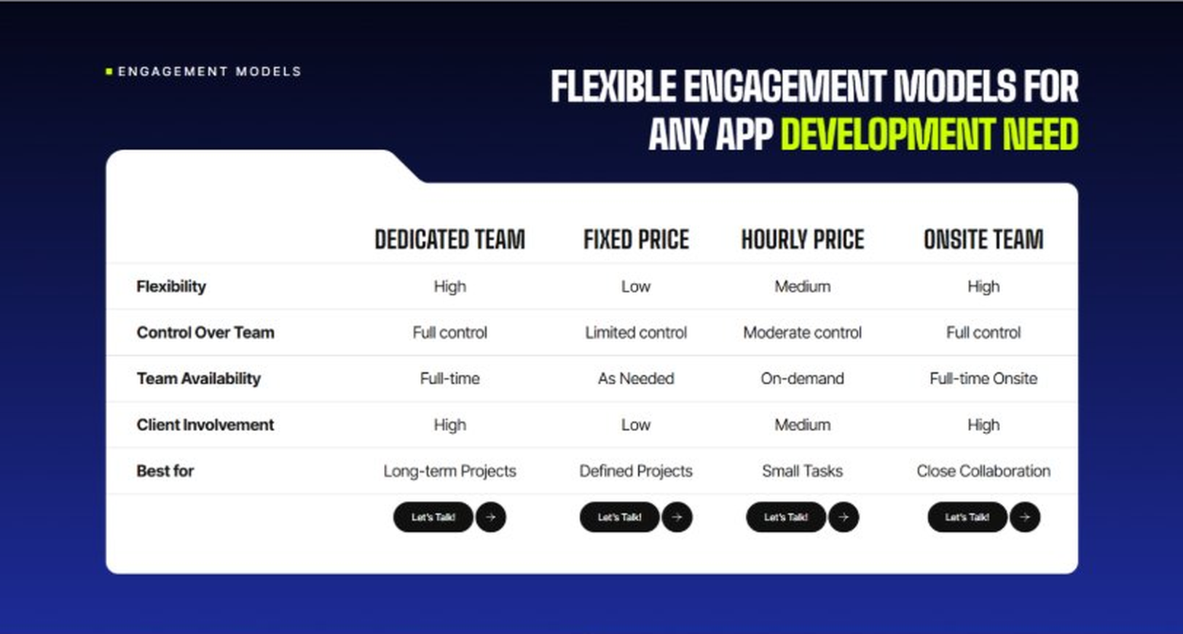
Current live page, www.appsters.io/industry
 | DETAIL
Status | No copy change
Build Notes | No new copy in the source document for this fold. Keep the live block exactly as it is.
FOLD 12: Game App CTA
Game App CTA: Into Engaging Mobile Games
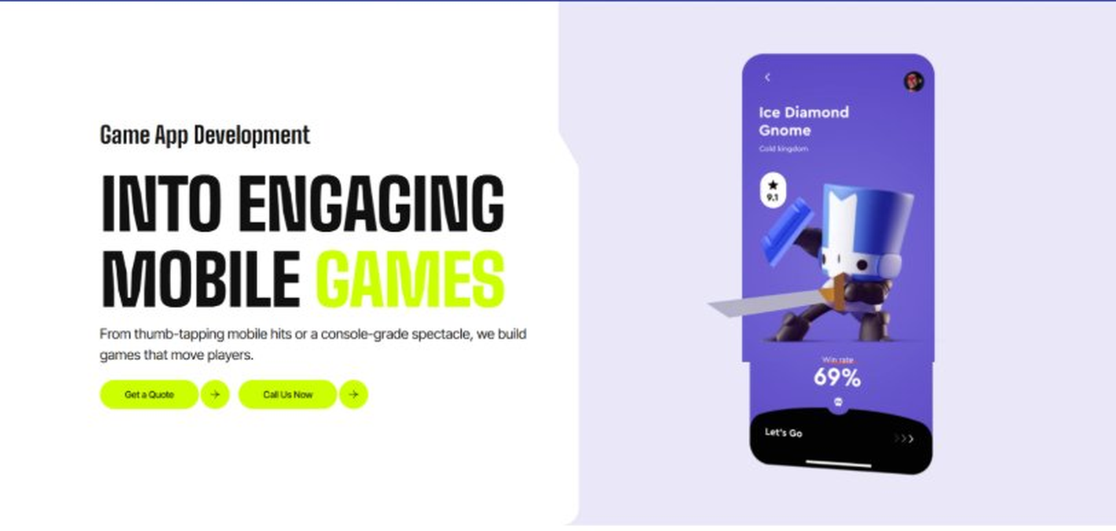
Current live page, www.appsters.io/industry
 | DETAIL
Status | No copy change
Build Notes | No new copy in the source document for this fold. Keep the live block exactly as it is.
FOLD 13: Collaboration And Client Logos
Collaboration And Client Logos
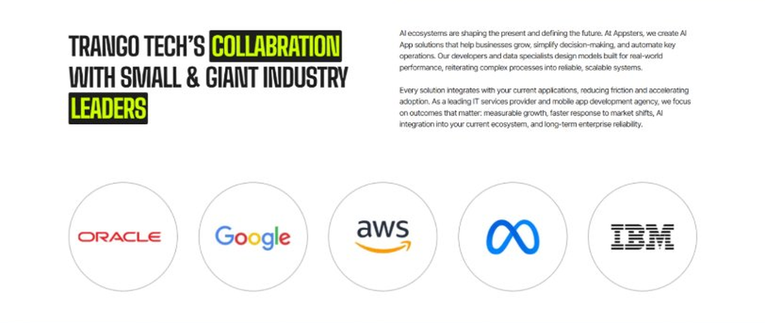
Current live page, www.appsters.io/industry
 | DETAIL
Status | No copy change
Build Notes | No new copy in the source document for this fold. Keep the live block exactly as it is.
QA Flag | Live heading reads "Trango Tech’s Collabration with Small & Giant Industry Leaders". That is a competitor name plus a spelling error sitting live on the page. Fix regardless of this content drop.
FOLD 14: Recognition CTA Banner
Recognition CTA Banner
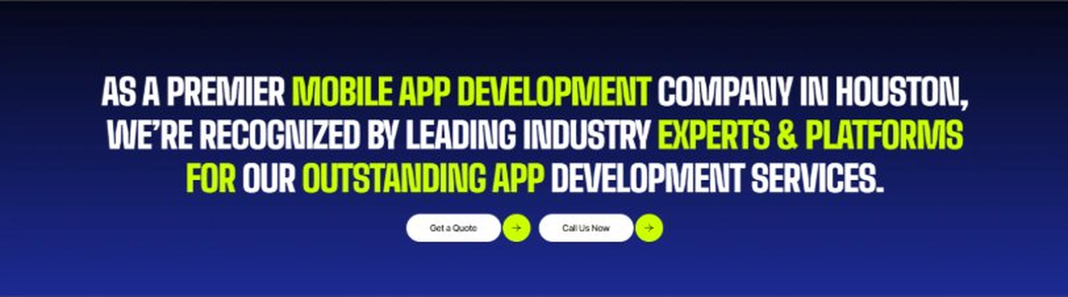
Current live page, www.appsters.io/industry
 | DETAIL
Status | New copy applied
Build Notes | Live block holds a headline and two CTA buttons. New copy supplies the heading and paragraph.
Copy For This Fold
PAGE ELEMENT | COPY (WORD FOR WORD)
H2 (Section Heading) | Every Mile Generates Data. Is Your Platform Ready To Use It?
Body Copy | Every day you wait is a day another dealership or fleet operator gets ahead on connected vehicle technology. Let's build an Automotive app that keeps drivers informed and vehicles running. Talk to Appsters today, and let's figure out what your first release actually needs to look like.
FOLD 15: Market Presence And Office Map
Market Presence And Office Map: Expand Your Market Presence
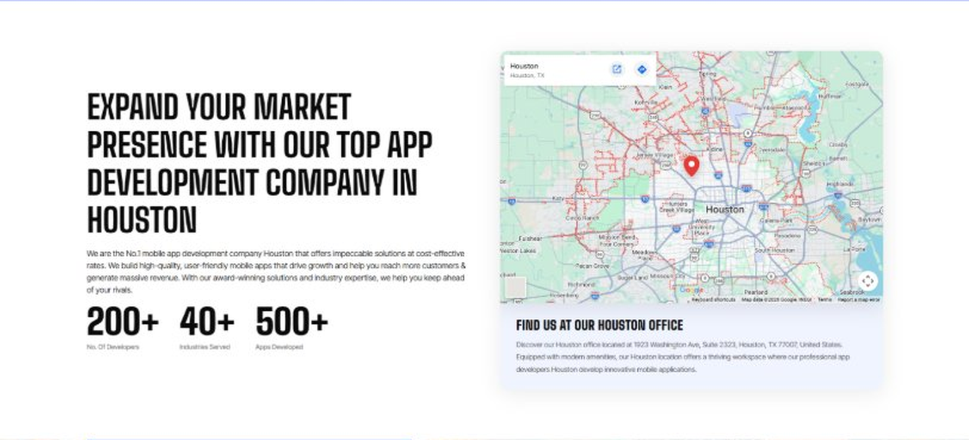
Current live page, www.appsters.io/industry
 | DETAIL
Status | New copy applied
Build Notes | Live block holds a heading, a paragraph, three counters and the office map. New copy supplies the heading and paragraph.
Copy For This Fold
PAGE ELEMENT | COPY (WORD FOR WORD)
H2 (Section Heading) | Food Ordering App Development Company Expertise Behind Every Automotive Platform We Build
Body Copy | As a team that knows how to develop mobile Automotive apps at scale, we bring the same rigor to embedded commerce and delivery-fleet features. Our engineers have shipped AI-based food delivery apps, telematics systems, and dealership platforms, giving us a deeper bench than studios that only build dashboard UIs. React Native, Swift, Kotlin, Node.js, and OBD-II integration protocols form our core stack, paired with AI models tuned for predictive maintenance, route optimization, and fraud detection. Where most competitors treat vehicle data as an afterthought, we design it into the core experience from day one.
FOLD 16: Portfolio
Portfolio: Quick Glimpse On Our Portfolio

Current live page, www.appsters.io/industry
 | DETAIL
Status | New copy applied
Build Notes | Live block holds a heading, a paragraph and one CTA. New copy holds an intro plus 4 named product cards. Source document marks this fold design TBD.
Copy For This Fold
PAGE ELEMENT | COPY (WORD FOR WORD)
H2 (Section Heading) | Automotive Products Engineered For Long-Term Driver Trust
Body Copy | Appsters builds automotive platforms that behave like long-term infrastructure, not a one-time dealership app. Our solutions stand out because they blend telematics, connectivity, and driver behavior analytics in one stable system. Every product is architected for reliability, safety, and real value across the vehicle's lifetime.
Product 1 Heading | DriveSync
Product 1 Copy | DriveSync is a connected car companion app that gives drivers remote start, diagnostics alerts, and maintenance scheduling from one screen. Real-time vehicle health data reaches drivers before a small issue becomes an expensive one.
Product 2 Heading | FleetGuard
Product 2 Copy | FleetGuard is a fleet monitoring app built for logistics and rental companies managing hundreds of vehicles. Live location tracking, driver behavior scoring, and predictive maintenance alerts keep vehicles on the road and out of the shop.
Product 3 Heading | DealerDesk
Product 3 Copy | DealerDesk is a dealership management app that connects inventory, service scheduling, and customer communication in one dashboard, cutting the back-and-forth between sales, service, and front desk staff.
Product 4 Heading | ServiceLoop
Product 4 Copy | ServiceLoop is a customer-facing service app that lets drivers book appointments, track repair status, and approve additional work in real time, replacing phone tag with something both sides can actually see.
Source document note: Portfolio fold, design TBD after content
FOLD 17: Tech Stack Tabs
Tech Stack Tabs: Mobile App Development, A Tech Stack For The Bold
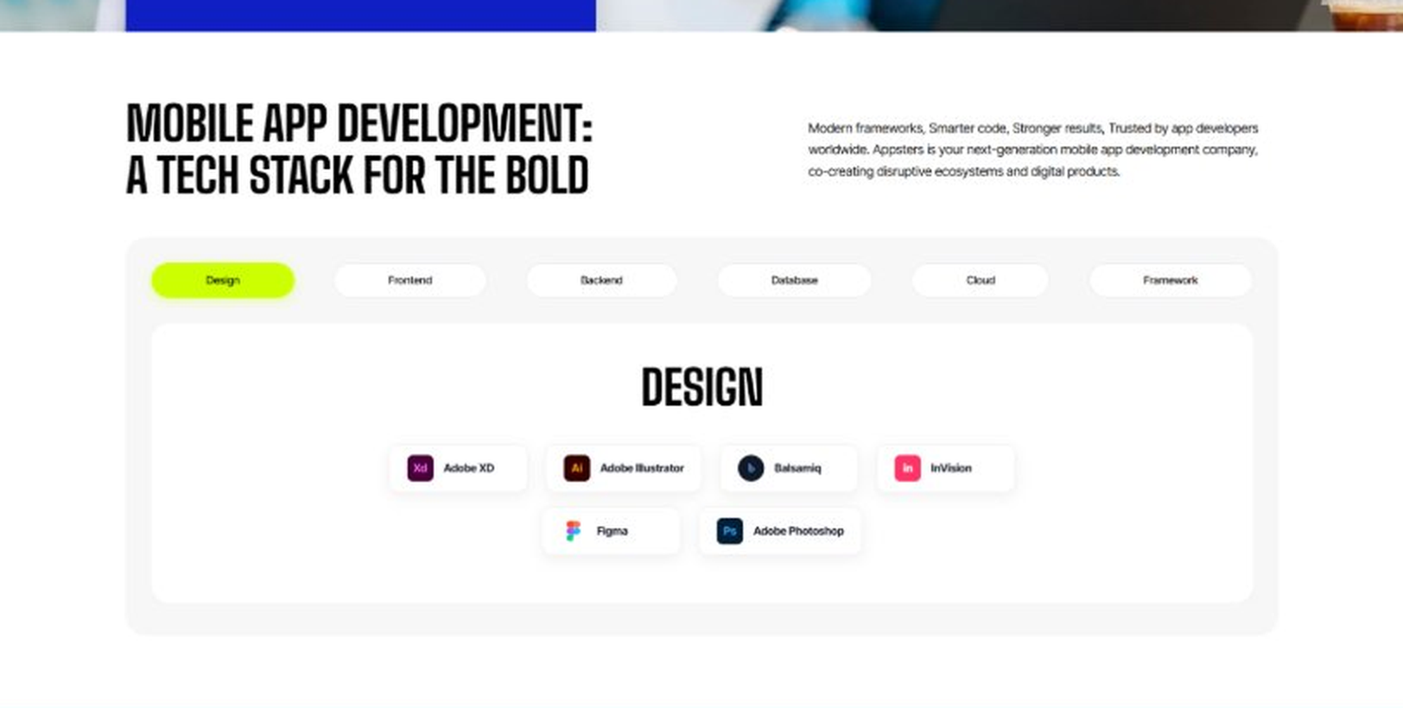
Current live page, www.appsters.io/industry
 | DETAIL
Status | New copy applied
Build Notes | Live block holds 6 category tabs with tool logos. New copy supplies the heading and paragraph, the tab contents stay as they are.
Copy For This Fold
PAGE ELEMENT | COPY (WORD FOR WORD)
H2 (Section Heading) | Technology Stack That Powers High-Performance Automotive Applications
Body Copy | Our engineering foundation supports live telemetry, heavy sensor data, and platform-wide scalability. Through our Automotive application development services, we use Swift, Kotlin, Flutter, React Native, Node.js, OBD-II and CAN bus integration protocols, and secure cloud infrastructure alongside AI-driven diagnostics engines. Every stack decision reinforces reliability, safety, and long-term flexibility so your platform can grow without a rebuild.
FOLD 18: Process
Process: App Development Process
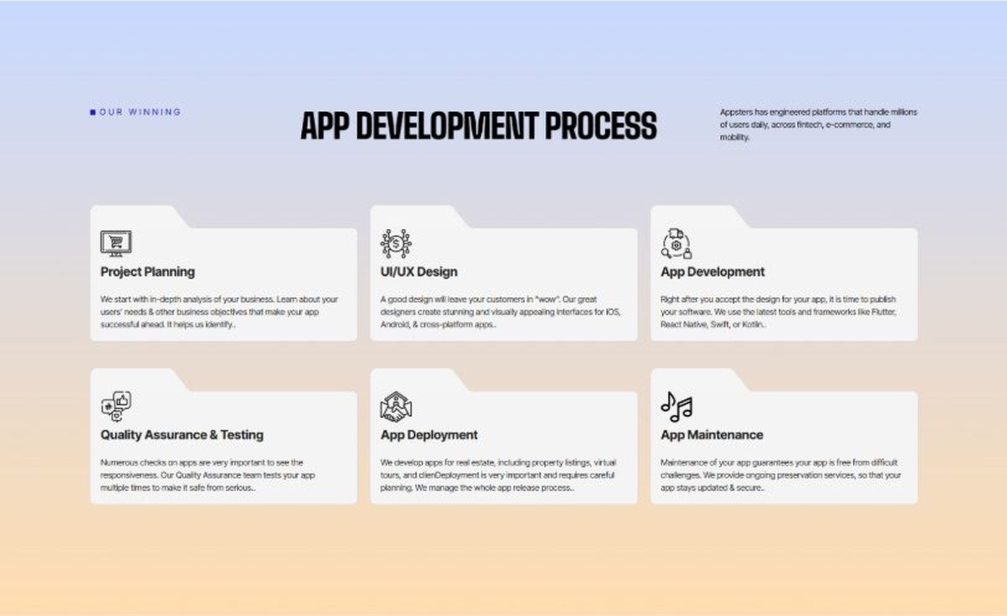
Current live page, www.appsters.io/industry
 | DETAIL
Status | New copy applied
Build Notes | Live block holds 6 step cards. New copy holds 8 steps. Either widen the block to 8 or merge two steps.
Copy For This Fold
PAGE ELEMENT | COPY (WORD FOR WORD)
H2 (Section Heading) | Automotive App Development Process Built For Platforms That Actually Ship
Body Copy | An automotive platform needs more than a clean dashboard. It needs structure, clarity, and a process engineered for safety, scale, and reliability from day one. Our Automotive app development process aligns product goals with technical roadmaps so every phase moves with intention.
Step 1 Heading | App Idea & Research
Step 1 Copy | Every project begins with structured discovery, where our teams map driver behavior, dealership workflows, and vehicle data requirements. We benchmark performance against existing platforms and define what will actually improve the driving or ownership experience. By the time research closes, the product's purpose, risks, and growth path are already clear.
Step 2 Heading | Strategic Planning & Consultation
Step 2 Copy | Here we translate research into a measurable plan. Our strategists define the technical architecture, hardware integration needs, and delivery milestones needed to build your AI Automotive mobile app the right way, from the first sprint.
Step 3 Heading | Wireframing & Prototyping
Step 3 Copy | We turn ideas into tangible user journeys. Wireframes capture dashboard layouts, driver interaction flows, and dealership interfaces in a visual structure stakeholders can react to before a single line of code gets written.
Step 4 Heading | App Development
Step 4 Copy | This is where engineering takes over. Our developers implement telematics integration, diagnostics systems, and dealership tools with the same discipline a food app development company applies to order accuracy and uptime. Development stays sprint-driven and transparent throughout.
Step 5 Heading | Expert QA & Testing
Step 5 Copy | Quality assurance covers far more than bug hunting. We validate hardware connectivity, data accuracy under poor network conditions, and cross-device behavior. Only stable, predictable behavior earns approval to move forward.
Step 6 Heading | App Launch
Step 6 Copy | Launch is a coordinated rollout, not a leap of faith. We manage store compliance, metadata strategy, and final performance checks so your platform enters the market ready to handle real vehicle data traffic.
Step 7 Heading | Deployment
Step 7 Copy | Our deployment pipelines are built for consistency and safety. We configure cloud infrastructure, optimize for real-time telemetry at scale, and calibrate autoscaling so your app performs the same for 100 vehicles as it does for 100,000.
Step 8 Heading | Maintenance & Support
Step 8 Copy | Post-launch, we keep monitoring connectivity performance, refining diagnostics logic, patching vulnerabilities, and responding to new compliance or app store requirements, so your platform keeps improving long after day one.
Source document note: Process fold, design TBD after content
FOLD 19: Blog Posts
Blog Posts: Our Related Blog Posts
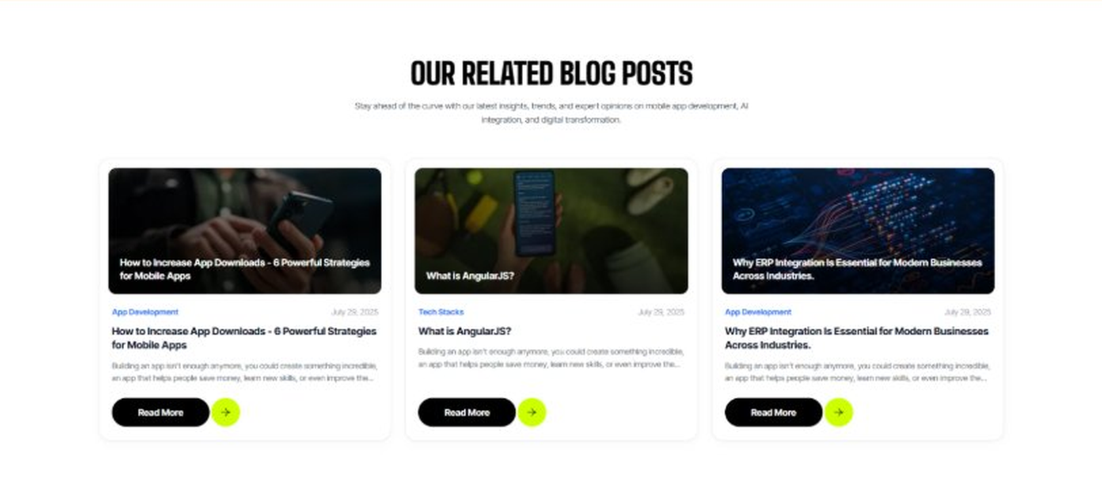
Current live page, www.appsters.io/industry
 | DETAIL
Status | No copy change
Build Notes | No new copy in the source document for this fold. Keep the live block exactly as it is.
FOLD 20: FAQs
FAQs: Your Questions, Our Clarity
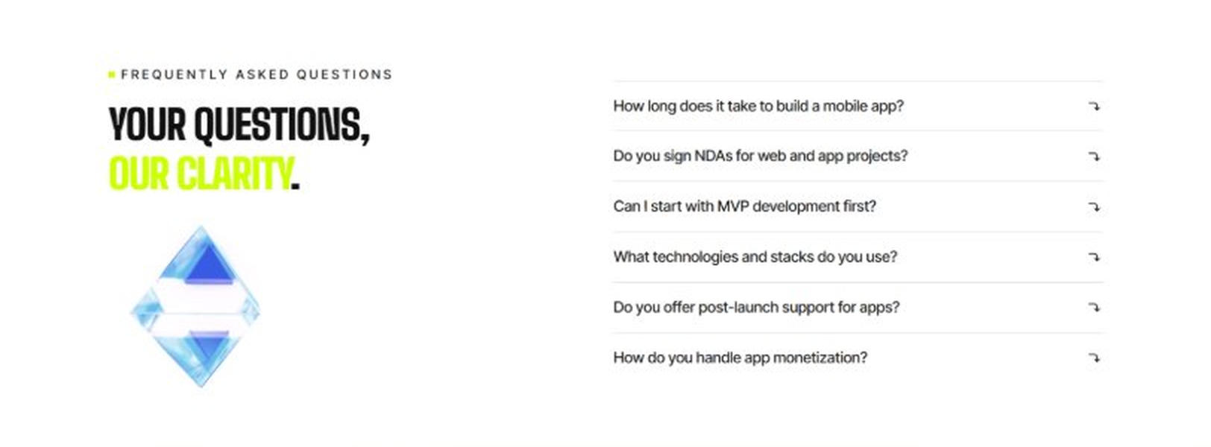
Current live page, www.appsters.io/industry
 | DETAIL
Status | New copy applied
Build Notes | Live block holds 6 accordion rows. New copy holds 6 questions and answers. Clean one to one fit.
Copy For This Fold
PAGE ELEMENT | COPY (WORD FOR WORD)
H2 (Section Heading) | Frequently Asked Questions
FAQ 1 Question | How long does it typically take to build a fully functional automotive app?
FAQ 1 Answer | Timelines depend on hardware integration, fleet size, and telemetry requirements. Most projects take 12 to 20 weeks for a stable release, including design, engineering, QA, and pilot testing. As an automotive app development company, we provide clear milestones from day one.
FAQ 2 Question | Can Appsters build an AI Automotive app with predictive maintenance?
FAQ 2 Answer | Yes. We build AI Automotive apps with predictive maintenance, driver scoring, and automated diagnostics baked into the core architecture, not added as an afterthought.
FAQ 3 Question | Do you support in-app commerce features like a food delivery app development company would?
FAQ 3 Answer | Absolutely. Many of our Automotive app developers have direct experience building ordering and delivery flows for fleet operators, so we can embed commerce features directly into your platform where it makes sense.
FAQ 4 Question | What makes Appsters different from other Automotive mobile app development company options?
FAQ 4 Answer | We treat hardware reliability, safety, and telemetry accuracy as core product decisions, not add-ons. Most Automotive app development companies focus on UI first and scale later. We do both from the start.
FAQ 5 Question | Can you integrate with existing OEM telematics hardware?
FAQ 5 Answer | Yes. We have direct experience connecting to a wide range of OBD-II and OEM telematics systems, so you're rarely starting from a completely blank hardware slate.
FAQ 6 Question | What ongoing support do you provide after launch?
FAQ 6 Answer | Our Automotive app development services include post-launch monitoring, feature updates, compliance checks, and infrastructure scaling, so your platform keeps improving long after release.
FOLD 21: Locations
Locations: Our Global Presence
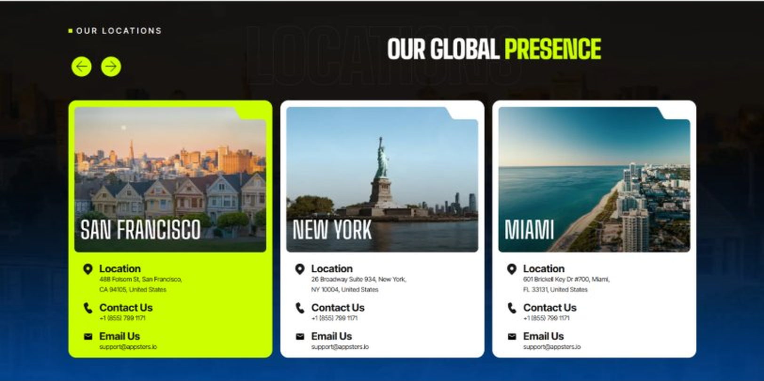
Current live page, www.appsters.io/industry
 | DETAIL
Status | No copy change
Build Notes | No new copy in the source document for this fold. Keep the live block exactly as it is.
FOLD 22: Contact Form
Contact Form: Connect With Us
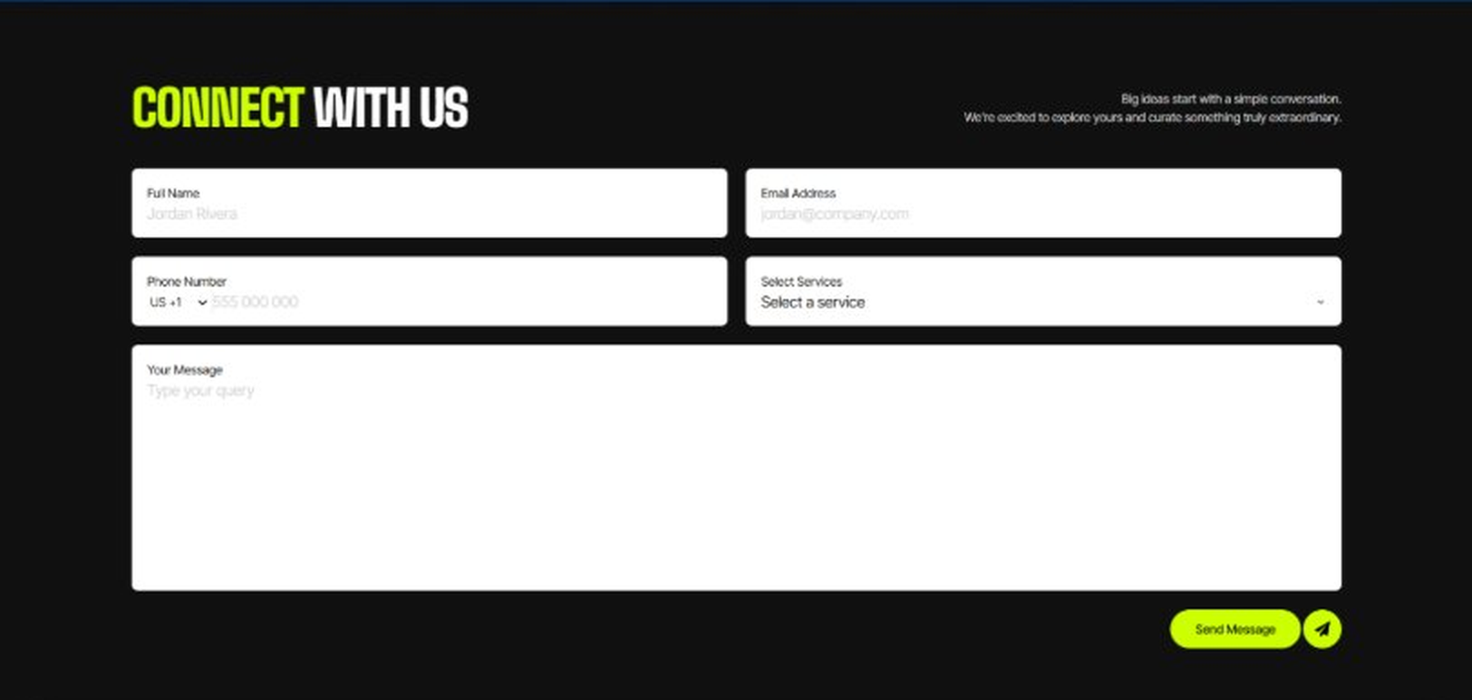
Current live page, www.appsters.io/industry
 | DETAIL
Status | No copy change
Build Notes | No new copy in the source document for this fold. Keep the live block exactly as it is.
FOLD 23: Footer
Footer
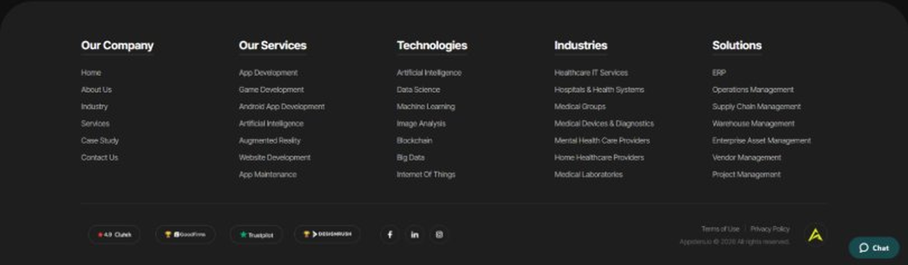
Current live page, www.appsters.io/industry
 | DETAIL
Status | No copy change
Build Notes | No new copy in the source document for this fold. Keep the live block exactly as it is.
NEW BLOCKS REQUIRED
The three blocks below are in the source content but have no matching section anywhere on the current /industry page. Each one needs a new block built.
NEW BLOCK: Distinct Features That Set Our Automotive Apps Apart
 | DETAIL
Status | No equivalent block on the live page
Placement | Suggested placement: directly after Fold 5, reusing the services card grid styling.
Copy For This Block
PAGE ELEMENT | COPY (WORD FOR WORD)
H2 (Section Heading) | Distinct Features That Set Our Automotive Apps Apart
Feature 1 Heading | Dashboard & Admin Panel
Feature 1 Copy | A centralized control center gives your team visibility into fleet health, service schedules, and customer activity without digging through raw data.
Feature 2 Heading | Push Notifications
Feature 2 Copy | Smart, behavior-based notifications alert drivers to maintenance needs and service reminders at the right moment instead of burying them in noise.
Feature 3 Heading | Digital Menu
Feature 3 Copy | A structured digital catalog lets customers browse service packages, parts, and accessories without a call to the service desk.
Feature 4 Heading | Order Tracking
Feature 4 Copy | Real-time order tracking keeps customers informed on parts orders and service progress without repeated phone calls to the shop.
Feature 5 Heading | Social Media Integration
Feature 5 Copy | Direct sharing lets dealerships and drivers post reviews, milestones, and vehicle updates straight to their existing social platforms.
NEW BLOCK: Industries We Serve
 | DETAIL
Status | No equivalent block on the live page
Placement | Suggested placement: directly after Fold 10, as a card grid rather than tabs.
Copy For This Block
PAGE ELEMENT | COPY (WORD FOR WORD)
H2 (Section Heading) | Industries We Serve
Body Copy | One Codebase. Infinite Industries. Our web, app, and AI solutions are built to perform, scale, and adapt while setting industry standards and redefining what's possible for businesses everywhere.
Industry 1 Heading | Fintech
Industry 1 Copy | We co-create secure, compliant fintech apps that simplify payments, investments, and trading, using the same transaction infrastructure we build for service billing and fleet payments.
Industry 2 Heading | Healthcare
Industry 2 Copy | We develop HIPAA-compliant healthcare apps that bridge doctors, patients, and data, applying the same real-time telemetry systems we use for connected vehicle diagnostics.
Industry 3 Heading | Education
Industry 3 Copy | Our education apps gamify learning and power virtual classrooms, borrowing the same notification and scheduling systems we use for service appointment booking.
Industry 4 Heading | Real Estate
Industry 4 Copy | We design real estate apps that help buyers, sellers, and agents close deals faster, using the same location-based data infrastructure we build for fleet tracking.
Industry 5 Heading | Music
Industry 5 Copy | We create streaming apps and artist marketplaces, applying the same connectivity infrastructure that keeps our in-vehicle entertainment integrations reliable.
Industry 6 Heading | Social Media
Industry 6 Copy | We build social platforms that are scalable and sticky, drawing on the same high-availability infrastructure that keeps our automotive apps running under fleet-wide load.
Industry 7 Heading | Logistics
Industry 7 Copy | We power logistics apps with route optimization and real-time tracking, using the same telematics expertise behind our automotive fleet platforms.
Industry 8 Heading | Ecommerce
Industry 8 Copy | We build ecommerce apps with frictionless checkouts and AI product recommendations, backed by the same parts and inventory logic we use across dealership platforms.
NEW BLOCK: Advanced Technologies That Power Our Automotive Apps
 | DETAIL
Status | No equivalent block on the live page
Placement | Suggested placement: directly after Fold 17, reusing the services card grid styling.
Copy For This Block
PAGE ELEMENT | COPY (WORD FOR WORD)
H2 (Section Heading) | Advanced Technologies That Power Our Automotive Apps
Body Copy | As an automotive app development company built around what's next, we don't stop at dashboards and diagnostics. Every automotive app developer on our team stays current with tools that keep platforms competitive, from AI predictive maintenance to live commerce. Unlike most automotive app development companies still catching up on food ordering app development trends inside delivery fleet apps, we're already building AI-based automotive apps with these capabilities baked in.
Technology 1 Heading | AI Integrated Automotive Apps
Technology 1 Copy | We build AI Integrated Automotive Apps with predictive maintenance, driver behavior scoring, and automated diagnostics, catching problems before they turn into breakdowns.
Technology 2 Heading | Payment Gateway Integration
Technology 2 Copy | Secure, PCI-compliant payment gateway integration lets your platform handle service payments, subscription plans, and parts orders without third-party friction.
Technology 3 Heading | Cloud Solutions
Technology 3 Copy | Our cloud solutions keep telemetry-heavy platforms fast and reliable, with autoscaling infrastructure built to absorb fleet-wide data spikes.
Technology 4 Heading | MVP For Automotive Apps
Technology 4 Copy | When you need to validate an idea fast, our MVP for Automotive Apps approach gets a functional, testable product into real drivers' hands without a twelve-month build cycle.
Technology 5 Heading | API Integration
Technology 5 Copy | We connect your platform to OEM systems, parts suppliers, and other automotive ecosystems through clean, well-documented API integration.

